 |  |  | SOW Coversheet  Version 1.1  Last Updated: November 29, 2006
Instructions: This SOW Coversheet must be filled out completely prior to SOW submission to CRB/DRB - the SOW will not be processed without this information. Keep this SOW Coversheet as part of the SOW document during the internal FAST review processes; it will be removed before presentment to the end-customer.

Customer Data |  |  | FAST Team
Customer Name |  | Singapore Press Holdings Limited | Sales Representative |  | Charles
Customer PO # (if known) |  |  | Sales Engineer
Customer Bill-To: |  |  | SCS Project Manager  (if known) |  | Alex Chua
Products
List FAST products required to deliver the proposed solution

SOW Data
__x___ New SOW  _____ Change Request (CR) |  |  | _____ Fixed Fee  _____ Time and Materials (T&M)
SOW/CR Name and Number |  |  | SOW/CR Value  (actual if Fixed Fee, estimate if T&M)
Not-to-Exceed Amount  Delivery |  |  | Not-to-Exceed Amount  T&E
Estimated Project Start Date |  |  | Estimated Project Completion Date
Estimated Number of Project Man Hours |  |  | Billing Penalties Associated with Missing Milestones or Deliverables (if applicable)
Billable Milestones
Billable Milestone #1 | Milestone Name: |  |  | Milestone Target Date:
Billable Milestone #1 | Revenue Tied to Milestone:
Billable Milestone #2 | Milestone Name: |  |  | Milestone Target Date:
Billable Milestone #2 | Revenue Tied to Milestone:
Billable Milestone #3 | Milestone Name: |  |  | Milestone Target Date:
Billable Milestone #3 | Revenue Tied to Milestone:
Billable Milestone #4 | Milestone Name: |  |  | Milestone Target Date:
Billable Milestone #4 | Revenue Tied to Milestone:


Fast International AS
Torggata 2-4-6,
N-0181 Oslo,
Norway

Statement of Work
No. 1

SPH
IP Tracking
Table of Contents

Preamble 1
Project Description 1
Background 1
Scope of Work 1
Assumptions 2
Change Management 2
Acceptance 3
Project Management 3
Pricing 4
Activities and Estimates 4
Duration 4
Fees 5
Payment Terms 5
Travel and Expenses 5
Signatures 5

[Upon completion of SOW, right-click on table of contents and select Update Field. ]

Preamble | Section
Preamble | 1
This Statement of Work (“SOW”), dated May 22, 2008, is an agreement (the “Agreement”) between:
Fast International AS  Torggata 2-4-6,  N-0181 Oslo,  Norway | and | Singapore Press Holdings Limited  1000 Toa Payoh North  News Centre  Singapore 318994

This Agreement (also referred to as the “SOW” and the “Statement of Work”) is governed by the terms and conditions of the Professional Services Agreement (“PSA”) between Fast International (“FAST”) and Singapore Press Holdings (“Customer”), dated May 22, 2008. It describes the services to be provided by FAST to the Customer. Unless otherwise defined herein, all capitalized terms shall have the meanings set forth in the PSA.

Project Description | Section
Project Description | 2
This section describes the general activities that will be undertaken in the course of creating the deliverables. The FAST Project Manager will work with the Customer to produce more detailed definitions of the general activities, as appropriate to the project and as mutually agreed to by FAST and the Customer.

Background
Main board-listed Singapore Press Holdings Limited (SPH) is the leading media organization in Singapore, with one of the region's most advanced printing assets. It is licensed to publish 14 newspapers in four languages in Singapore and together, these have a circulation of more than one million copies a day. SPH also publishes and distributes more than 90 periodicals in Singapore and the region. In addition, it owns a 40 percent stake in MediaCorp Press Pte Ltd, which publishes free newspaper Today. Every day, SPH newspapers are read by 2.7 million individuals, or 83 percent of persons above 15 years old.
Apart from its core business as a newspaper and magazine publisher, SPH also provides Internet portal services with online news, archive news retrieval through its Internet arm, the SPH Internet Business Unit.
SPH operates two radio stations, Radio 100.3 FM in Mandarin and Radio 91.3 FM in English, under a 80 percent-owned joint venture company, SPH UnionWorks, with NTUC Media. SPH also maintains a business interest in free-to-air television through a 20 percent shareholding in MediaCorp TV Holdings Pte Ltd, which operates channels 5, 8, U and TV Mobile.
SPH also has interests in shopping malls and residential condominiums, as well as outdoor advertising.
SPH core products are newspapers and magazines. Currently with 14 newspapers published, as well as more then 90 titles of magazines.
With some 1,000 journalists, including correspondents operating in 20 cities around the world, SPH is well-equipped with the talent and network to deliver quality news and information that covers both domestic and international markets. Its stable of 14 broadsheets and tabloids caters to the wide-ranging demographics of Singapore's multi-ethnic population, while its numerous periodicals appeal to the lifestyle needs of the people in Singapore as well as the region.
Through its comprehensive range of newspapers and magazines, SPH enjoys continued dominance in the Singapore advertising market, holding about 50 percent share of total advertising expenditure. Circulation of SPH newspapers continues to show growth despite the increasing popularity of the Internet.
For this project, SPH is focusing on the misuse of Intellectual Property of Newslink content.

Scope of Work
This section defines and constrains the general activities that will be undertaken in the course of fulfillment of this SOW. The FAST project manager will work with the Customer to produce a detailed definition of the specific activities as appropriate to the project and as mutually agreed upon by FAST and the Customer.
Tangible deliverables will include appropriate specifications, design, development, unit testing and technical documentation, except as already provided by product(s) separately licensed from FAST, as described in more detail below. Except as otherwise stated in task descriptions, work will be performed off-site at FAST facilities.
The implementation effort is comprised of:
1) Review and Refine Requirements
2) Design Solution
3) Develop Solution
4) Deploy Solution
5) Project Support

The following activities are defined to be in scope for this SOW:
1) Review and Refine Requirements
- FAST will review and refine requirement based on materials provided by the Customer.
- FAST will analyze data feeding requirements regarding how SPH Search opens their Directory and LWI.
- FAST will analyze the alert and reporting requirements
- FAST will review and analyze the infringement requirement based on materials provided by the customers
- FAST will define FAST ESP, Crawler, and database schema on the customer business requirements and provide install profiles for production environment.
2) Design Solution
- FAST will create configuration files such as index profile, search profile, and Document Processing pipelines, based on the requirements.
- FAST will provide the necessary ESP JDBC Connector configuration file/File Traverser/crawler command parameters to feed data/documents/web-pages.
- FAST will assist the Customer in SQL to retrieve seed list from database.
- FAST will assist the Customer in front end application technical design.
- FAST will assist the Customer in FQL executed by the Customer's search front end application.
- FAST will assist the Customer in designing a rank model.
- FAST will assist the Customer in determining data backup requirements, system monitoring requirements, and operation requirements.
3) Develop Solution
- FAST will develop custom Document Processing stages.
4) Deploy Solution
- FAST will install and setup initial configuration of FAST ESP, Crawlers in production environments.
- FAST will provide installation procedure documentation after setting up in production environment.
- FAST will perform initial data feeding.
- FAST will work together with the Customer and project team to test system integration testing in production environment.
5) Project Support
- FAST will attend meetings at the Customer site. The purposes of the meetings are for FAST to understand the Customer requirements and a status of the project, as well as for the Customer to understand a status of FAST's tasks
- FAST will address the customer's question/inquiries regarding FAST products via email and/or phone calls, time limited to a maximum of 18 days effort.

Red Nano Keyword search
Red Nano Directory

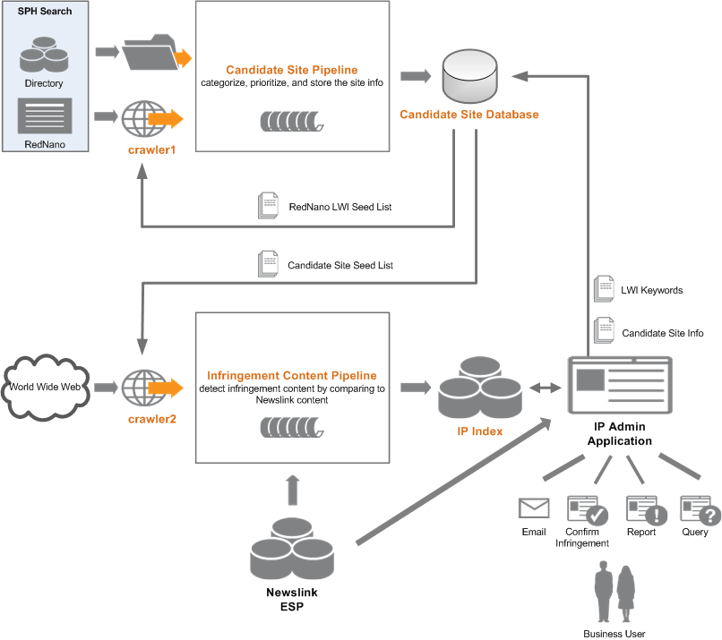

Assumptions
This Statement of Work is based on information provided by the Customer and is subject to external factors. Successful completion of this project is predicated on the following assumptions, which otherwise represent risk to delivery schedule and cost. Provided that nothing herein shall exempt FAST from discharging its duties and obligations under this Agreement, to the extent that such duties and obligations remain unaffected by a failure of any Assumptions to be correct.
- Customer will accept and execute PSA and SOW prior to start of work.
- Customer will provide all information required for proper solution design and architecture as requested by FAST.
- Customer will provide development hardware as specified by FAST prior to start of development.
- Customer will provide product hardware as specified by FAST prior to start of deployment.
- Customer personnel with appropriate skills and knowledge will be available as requested by FAST during the course of the engagement.
- Customer will resolve all open issues and action items in a timely manner.
- Normal working hours are between 9:00 and 17:00, and FAST personnel are expected to perform Services only within those hours unless agreed otherwise by FAST.
- Sufficient scoping and design activities have been completed by the customer jointly with FAST before commencement of the work described in this SOW.
- Customer will review and approve solution design prior to the start of development.
- Customer will host and operate all services.
- Customer will perform integration of FAST ESP to any external systems.
- FAST will provide technical advice on integration touch-points.
- FAST will not perform any modification to external systems or any modifications to workflow in those systems.
- Customer will prepare meta data for all data sources.
- FAST is not responsible for timeline or deliverables to the extent they are affected by Customer’s failure to comply to these Assumptions.
- SPH ITDAPINT will build the Front End which provides the general infringements reports and be a general tool for staff investigating and searching for infringements.
- If IP ESP instance is to be run on the same machine as Newslink ESP instance then Sun VM is require. SPH ITD will install and configure the VM ware on the machine and this should be completed before the installation of the ESP instance.

Change Management
The FAST Project Manager will work with the Customer to produce more detailed definitions of the services and deliverables, as appropriate to the project and as mutually agreed to by FAST and Customer. These mutually accepted definitions will constitute the “Project Baseline” and be governed by this SOW.
Any non-trivial adjustments, additions, and deletions to the “Project Baseline”, or “Scope of Work” of this SOW will be handled via the following process:
- The adjustment is framed as a “Change Request”, from Customer to FAST.
- FAST reviews the Change Request and responds, stating the impact of the change in terms of cost (hours of additional work or material expenses), required changes to the project schedule, or increased project risk.
- Customer then accepts or rejects the change. By accepting the change, Customer becomes liable for all stated project impact, including costs, schedule and risks. Payment for any increased costs will be governed by this SOW.
The definition of a “non-trivial adjustment” is any adjustment that (a) requires additional work or expenditures by FAST beyond the total specified in this SOW, (b) requires a change in project schedule, or (c) creates additional project risks that may jeopardize the success of the project.

Acceptance
FAST shall provide formal notification to the Customer upon completion of the deliverables as specified in this SOW. This SOW will be deemed completed when the deliverables and requirements as specified in the Scope of Work and Deliverables Section have been met and demonstrated (“acceptance criteria”). Additional acceptance criteria may be mutually agreed upon based on solution design. Customer shall, within five business days from the day on which FAST delivers notice of completion, carry out the agreed upon acceptance tests to validate whether the deliverables meet the acceptance criteria
Acceptable reasons for rejection of the project are limited to the following:
- Requirement(s) specified in the SOW are not met.
- Deliverable(s) are not completed according to agreed upon specifications.
- Presence of critical defect(s), which result in complete or substantive failure of a functional component.
If Customer rejects any of the deliverables, Customer must provide written notice to FAST of the rejected deliverables and the reasons for rejection. FAST shall work with the Customer to remedy the specified defects and re-deliver corrected deliverables to the Customer. This process will be repeated until the deliverables meet the acceptance criteria.
A deliverable shall be deemed to have been accepted by Customer upon the occurrence of any of the following events:
- Customer fails to give written notice of rejection of the deliverable (or corrected deliverables), which notice identifies the extent to which such deliverable does not comply with the acceptance criteria, within five business days after the receipt of such deliverable.
- Customer gives written notice of acceptance.
- Customer uses the deliverable for any purpose other than testing.

Project Management
Project management of the described work is the responsibility of FAST Solution and Customer Services, except where noted otherwise, and will include project planning and control, resource allocation and management, and asset tracking.
SPH’s roles and responsibilities are as follows:
Role | Name(s) | Role Function
Business Project Sponsor | Leslie | Sponsor of the project with the Customer
Project Steering Group | SPH IBU | Review progress against plan and approve project continuation at control points. Provide ad hoc guidance.
Project Manager | Ben | Responsible for day to day progress of project within agreed timescales, requirements and costs
Technical Owner | Francis | Manager of Infrastructure Delivery Team
Technical SME’s |  | Technical experts
Content Owner | Idris | Assumed ownership of content for purposes of this project particularly migration on to new hosting infrastructure.
Content Coordinators | IRC | Review and approve new and amended content prior to publishing on live system
Content Publishers | Sebastian | Produce new and amended content
Infrastructure | Ben/Francis | Produce solution design specification (SDS) the detailed design for the new hosting infrastructure including the FAST search tool.  Responsible for profiling new applications  Build and commission new infrastructure including non functional testing
Deliverables Approver | James/Liang Moung | Sign off acceptance of deliverables
Test manager | Sebastian | Responsible from the customer to test the solution
Test performer(s) | Sebastian | People that will be in the test team, responsible to perform the testing
Engineer | Cai Qing | Integration between FAST and external systems

One or several roles can be held by the same person in SPH.
FAST’s roles and responsibilities are as follows:
Role | Name(s) | Role Function
Project Manager | Alex Chua | Responsible for tracking, reporting and overall delivery.
Technical Lead | Zhong Lun | Responsible for the architecture and design
Architect | TBD | FAST Solution architecture and design
Quality Assurance | TBD | Quality assurance of deliverables
Engineer | TBD | Installation and configuration of the system

Pricing | Section
Pricing | 3

Activities and Estimates
All estimates are considered preliminary until the final project plan is accepted by both parties.
Task | Deliverables | Effort (Days) | Price (USD)
Specification and Planning | Detailed Specification, detailed Project Plan | 25 | 40,000.00
Design work for the Front End | Specification for the Front End features | 10 | 16,000.00
Customization | Tasks needed to implement custom functionality | 15 | 24,000.00
Installation | Tasks to install and configure the system | 5 | 8,000.00
Tuning and Testing | Adjustments and testing of the system to run properly | 10 | 16,000.00
Training and Documentation | Sufficient training to operate and maintain installation | 10 | 16,000.00
Project Management |  | 15 | 24,000.00
TOTAL |  | 90 | 144,000.00

Duration
Project duration is an estimate based on the scope of work described herein, and is predicated on assumptions set forth herein. Estimated duration represents the engagement term in business days. In the event that assumptions do not hold true, project duration may be necessarily extended.
Customer and FAST shall jointly determine the actual start date of the project, which shall be no later than 30 days after acceptance and signature of PSA and SOW.
Estimated Project Duration: 90 days

Fees
This is a fixed price SOW; Customer shall pay a fixed amount of USD$144,000.00 (“Fee”) for the Services described in the Scope of Work section. If additional Services are requested by the Customer and mutually accepted according to the terms of Change Management, Customer will pay for the additional services at a rate of USD$200 per hour.

Payment Terms
FAST will invoice:
- 30% of the Fee upon signature to the SOW
- 30% of the Fee upon system requirement sign-off (Milestone 1)
- 30% of the Fee upon user acceptance sign-off (Milestone 2)
- 10% of the fee upon expiry of the Warranty Period in accordance with the terms of the PSA
If additional charges are incurred in accordance with the terms above, FAST will invoice such charges monthly in arrears. Invoices are due within 30 days of the date thereof.
Charges will be billed to the following address: | Liang Moung  Singapore Press Holdings Limited  1000 Toa Payoh North  News Centre  Singapore 318994  Singapore  T: +65 6319 1756  E: liangm@sph.com.sg

Travel and Expenses
The price for this SOW does not include travel and living expenses. Customer is responsible for 100% of travel and expenses incurred during this engagement. FAST will bill Customer for this separately, monthly in arrears, with payment due 30 days from the date of invoice. All travel and expenses will conform to the FAST corporate Travel & Expense policy.

Signatures | Section
Signatures | 4
The terms of this Agreement are accepted and agreed to by both parties, and their respective authorized representatives have executed the Agreement below:

Fast International AS  Signature  Printed Name  Title Date | Singapore Press Holdings Limited  Signature  Printed Name  Title Date

